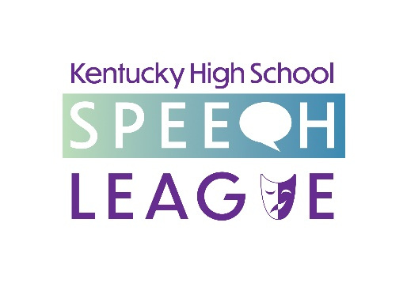
BLYTON BOOK AWARD 2025 Nomination Instructions

Blyton Book Awards are presented annually to two outstanding KHSSL students -- one from the Junior Division and one from the Senior Division. The awards are named for Dr. Gifford Blyton, former director of KHSSL.

To be eligible, a student must have (1) competed in KHSSL for at least two years, (2) proved to be superior in more than one KHSSL event, and (3) promoted speech, drama, and/or debate activities within their school, community, and state.

The Team’s coach must nominate the student. The coach must complete this nomination form and letter of reference. If necessary, additional pages may be used to detail only those activities mentioned on the nomination form. No pictures, transcripts, or grades may be included, nor should they be made reference to. Coaches may nominate more than one student.

To officially nominate a student, fill out and PRINT OFF this nomination form. Then turn in the printed copy, along with a printed personal letter of reference, no later than the start of first round of the appropriate State Speech tournament (Junior for 8th graders; Senior for 12th graders; Debate-only students are also eligible for the Blyton Book Award, but the appropriate deadlines apply for 8th or 12th grades).

The recipient of this award in each division will be chosen by an impartial panel selected by the Executive Director with the award presented at the State Championship Speech Tournament for that grade. The coaches of the winners will be notified prior to the awards ceremony.

Name of nominee Click here to enter text.

School Click here to enter text.

Name of Coach Click here to enter text.

Division Senior ☐ Junior ☐

Years Competing
2024-2025 ☐
2023-2024 ☐
2022-2023 ☐
2021-2022 ☐
2020-2021 ☐
2019-2020 ☐
2018-2019 ☐
2017-2018 ☐
2016-2017 ☐

What Events has your nominee been entered in over these years?

Click here to enter text.

- In the space below, please outline how your nominee has “proved superior” in more than one Event—you may list tournaments and final places.

Click here to enter text.

- In the space below, please outline how your nominee has “promoted speech, drama, and/or debate activities within his/her school, community, and state”.

Click here to enter text.

Please attach a letter of recommendation to this submission. Please do not refer to grades or transcripts, and do not submit any pictures. Print out all parts of the nomination and submit in one folder or envelope no later than the beginning of the appropriate first round State Speech tournament.

LATE APPLICATIONS ARE NOT ACCEPTED.

